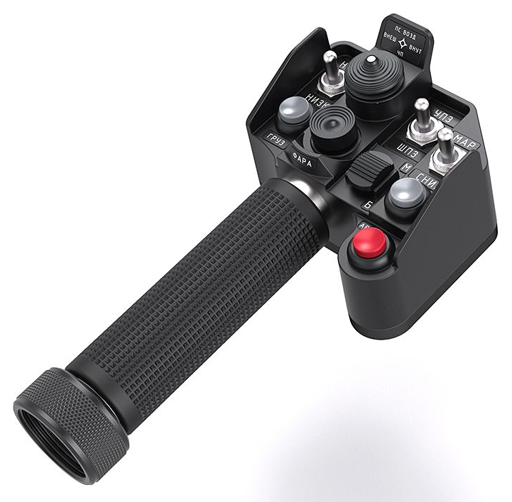
108 - Controls - Gunner - Collective Grip SharKa-50
U=Up, D=Down, F=Forward, B=Backward, L=Left, R=Right, P=Press, S-*=Shift-*, L-*=Long-*

Top hat -- Autopilot
- F/B/L/R: -- (no autopilot controls in front seat)
Bottom hat
- F/B/L/R: --
- P: Go to Shturm sight
- S-P: Steering arrow toggle
Black 2-way switch -- Communications
- F: (SRS radio 1 PTT)
- B: (SRS radio 2 PTT)
- S-F: (SRS radio 3 PTT)
- P: (VoiceAttack PTT)
- S-P: (VoiceAttack center mouse cursor)
Metal 3-way switch 1 (left)
- F: PKI sight adjust up (moves while held)
- B: PKI sight adjust down (moves while held)
- S-F: PKI sight lock
- S-B: PKI sight unlock
Metal 3-way switch 2 (middle)
- F/B: Shturm sight zoom toggle (Enlargement x3/x10)
Metal 3-way switch 3 (right)
- F: Select Station Next (for Shturm ATGM)
- B: Select Station Previous (for Shturm ATGM)
White button 1
- P: Launch countermeasures
White button 2
- P: Radiation reset
Red button
- P: OBSERVE switch
- S-P: DIAFR OPEN switch (enables off-boresight/out-of-params launch)

